AI BLOGNEST
Project Design Phase
Date | 25/09/2026
Team ID | SWTID-2026-6744
Project Name | AI BlogNest

Team Leader : KARTHICK M / Team Members : KANNAN G, SATHISH K,
HARIHARAN S
PHASE 3: PROJECT DESIGN PHASE

3.1 Project Architecture
BlogNest exposes structured endpoints handled by a layered server architecture.
Incoming requests pass through filter processing before reaching data services.
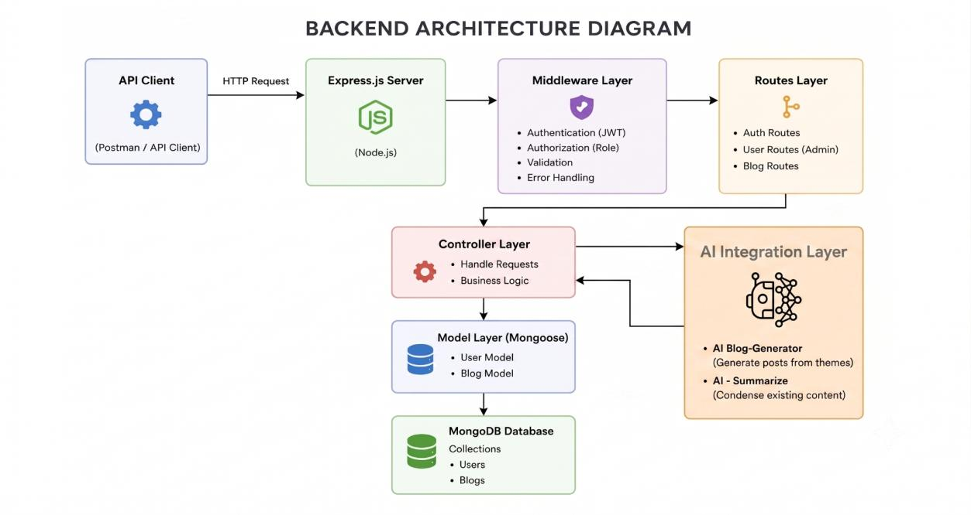 Fig 3.1 — Project Architecture

Components
- Interface: API tools like Postman query route paths to extract JSON entities.
- Express Server Gateway: monitors ports, maps HTTP methods
(GET/POST/PUT/DELETE), parses JSON payloads, handles CORS.
- Authentication & Role Matrix Middleware: extracts tokens from headers, validates signatures, checks role authorization for guarded routes.
- Granular Services (Logic Modules): enforce domain rules for blog lifecycles (Draft, Pending Approval, Scheduled, Published), comment queues, and reporting.
- Database Interface Layer: Mongoose translates application logic into native MongoDB queries.
- AI Flow (Service Integration): powers content automation via /api/ai/generate-blog and /api/ai/summarize, offloading text processing from controllers.
- BlogGenerator with AI: specialized service automating blog content generation via the AI Flow service.

3.2 Entity-Relationship (ER) Diagram
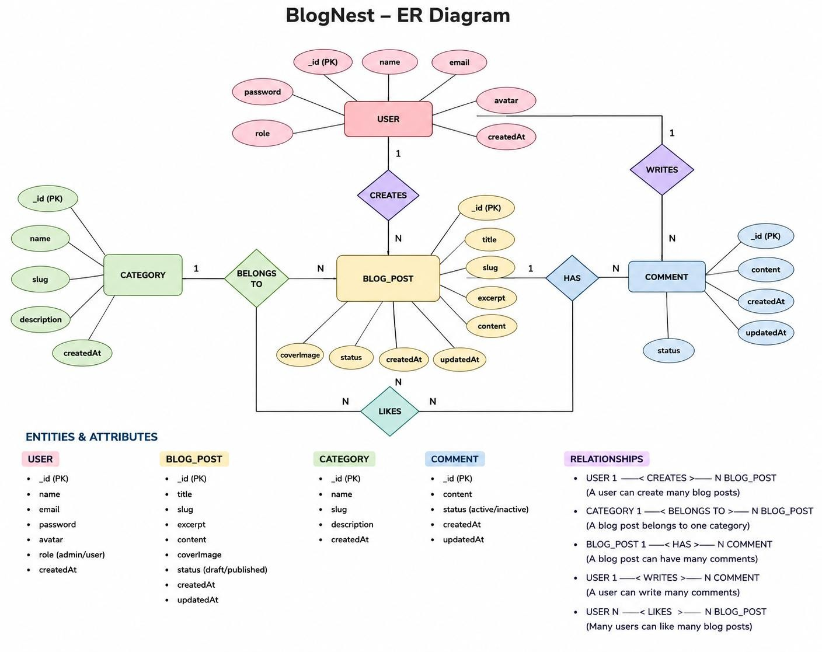
Fig 3.2 — ER Diagram

User Entity
- _id (Primary Key – ObjectId)
- name (String, Required)
- email (String, Required, Unique)
- password (String, Hashed, Required)
- role (String, Default: "reader")

Post Entity
- _id (Primary Key – ObjectId)
- userID (Foreign Key referencing User collection)
- name (String, Required — Title)
- photo (Object/String pathway link)
- message (String — core content body)
- likes (Number, Default: 0)
- timestamps (True)

Key Structural Mappings
- User → Post (One-to-Many): an author can submit multiple blog documents.
- User → Comment (One-to-Many): users can append multiple comments across posts.
- Post → Comment (One-to-Many): a blog post stores multiple referenced comments.

3.3 Key Features
- Role-Based Route Guarding — strict token checks block unauthorized tiers.
- CRUD Blog Execution Engine — full schema management of content, status, and assets.
- Categorization System — tag indices for filtering and discoverability.
- Comment Moderation Logic — endpoints for approved/pending/spam flags.
- Sanitization Safeguards — prevents XSS and NoSQL injection.
- AI-Driven Blog Generation Pipeline — LLM-based synthesis of full blog posts from prompts.
- Intelligent Content Summarization Engine — generates concise abstracts and metadata.

3.4 Roles and Responsibilities
- Admin: full override control — manage users, alter roles, prune comments, inspect logs.
- Editor: reviews pending drafts, publishes posts, handles category cleanup.
- Author: restricted access — creates posts bound to their own account.
- Reader: reads published content and posts comments as an authenticated user.
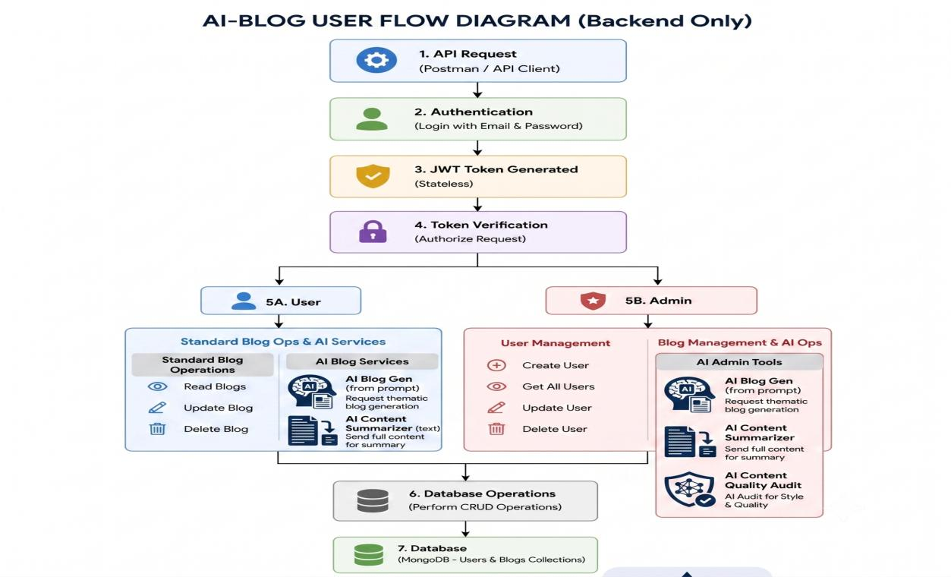
Fig 3.3 — User Flow

3.5 MVC Architecture Pattern
The system is structured around the Model-View-Controller pattern to fully decouple components:
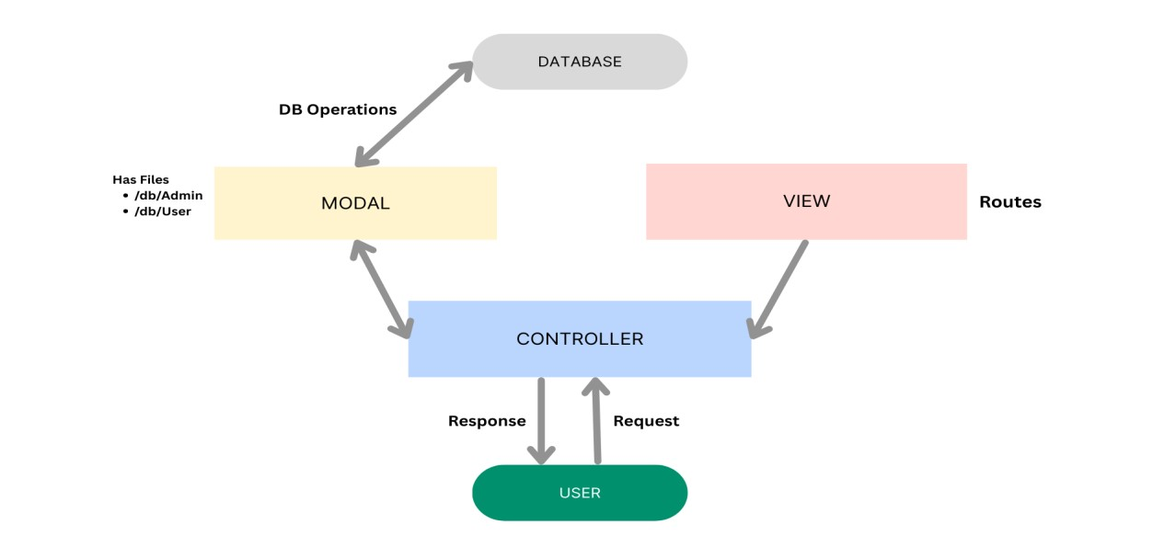
Fig 3.4 — MVC Pattern
- Model Layer: Mongoose schemas mapping fields into MongoDB collections, with defaults, indexing and validation.
- Controller Layer: captures requests, validates constraints, delegates to models, returns JSON responses.
- View Layer: as a headless backend, this is the API Routing Layer linking request paths to controller handlers.

